Basis Swap yield curves in K+

Software Version
Author(s) | Chirine BEN ZAIED
Type
Revised
File
Internal Re-viewer(s)
Sponsor(s)
Status

© Copyright Reuters 2006. All rights reserved.
Except as permitted by law, no part of this document may be reproduced or transmitted
by any process or means without the prior consent of Reuters.
Reuters, by publishing this document, does not guarantee that any information contained herein is and will remain accurate or that use of the information will ensure correct and faultless operation of the relevant service or equipment.
Reuters, its agents and employees shall not be held liable to or through any user for any loss or damage whatsoever resulting from reliance on the information contained herein.

Management Summary
The aim of this document is to present how the Basis Swap yield curves are built, the assumptions used and how they can be used for pricing CIRS.

Document history
Revision by | Date | Comments
Distribution List
Company | Date
Note
This memo is still a working document that should not be understood as a contractual commitment from Reuters.
The purpose of the following pages is to make you aware of the future improvements and to give you the opportunity to raise questions or issues. Your feedback will be appreciated.
Table of contents
1 Defining a Basis Swap yield curve 4
1.1 cross currency basis swaps 4
1.1.1 The assumptions 4
1.1.2 The calculations and bootstrapping 4
1.2 single currency basis swaps 5
1.2.1 The assumptions 5
1.2.2 The calculations and bootstrapping 5
2 Using the Basis Swap yield curves 6
2.1 cross currency basis swap deals 6
2.1.1 Example 6
2.2 single currency basis swap deals 9
2.3 cross currency basis swap deals with 2 Basis Swap yield curves 10

Defining a Basis Swap yield curve
The basis swap instrument is float vs. floating swap. It can be cross currency or single currency. The Principal can be exchanged or not at the beginning and maturity of the swap.

cross currency basis swaps

The assumptions
When building a Basis Swap yield curve in K+, the following assumptions are considered:
- The swap is between a ‘Ref’ Currency (cur1) and a ‘Flat’ Currency (cur2) where cur1 is different from cur2.
- Principal exchanged at beginning and end of the swap
- Discount Curve = Forward curve for the ‘Flat’ leg

The calculations and bootstrapping
Using the assumption 3, we get that the following NPV:
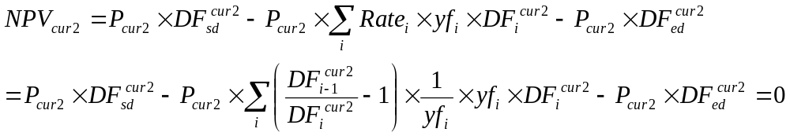

Thus we get that the NPV of the swap is as follows:

Then 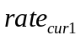 is computed using the ‘Underlying Curve’ with the definition of the ‘Ref Floating Rate’.
The discount Factors are then deduced by bootstrapping as for swap yield curves, using this formula:
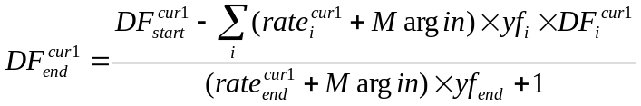

single currency basis swaps

The assumptions
For single currency basis swaps, usually there is no Principal exchanged. Thus, the following assumptions can be done:
- The swap is between ‘Ref’ Currency (cur1) = ‘Flat’ Currency (cur2)
- Principal not exchanged
- Discount Curve = Forward curve for the ‘Flat’ leg and is the same as the Forward curve for the ‘Ref’ leg

The calculations and bootstrapping
Using the assumptions, we get the following NPVs:
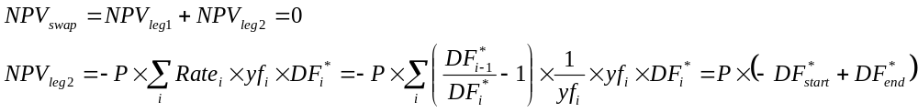And
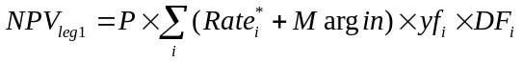
Where Rate* and DF* are taken from the Underlying Curve, and DF correspond to the Basis Swap yield curve.
Therefore, the formula becomes:
The floating rate is computed using the ‘Underlying Curve’ with the definition of the ‘Ref Floating Rate’.
The DF* are also taken form the Underlying Curve.
And the Basis Swap yield curve DF are then deduced by bootstrapping as for swap yield curves, using this formula:
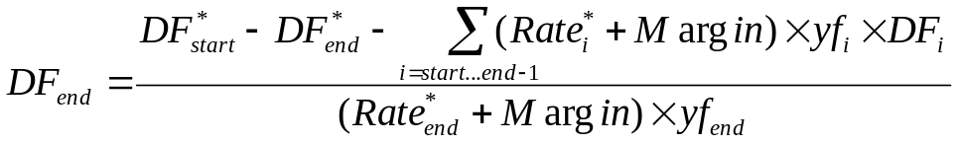

Using the Basis Swap yield curves

cross currency basis swap deals
To be correctly priced by the Basis Swap yield curves, the Basis Swap deals need to have the same assumptions as the curve:
- Principal exchanged at beginning and end
- Floating Rate = ‘Ref floating Rate’ as in the definition of the curve (same tenor at least)
- Discount Curve = Forward curve for cur2
- Discount Curve = Basis Swap yield curve for cur1
- Forward Curve = ‘Underlying Curve’ for cur1

Example

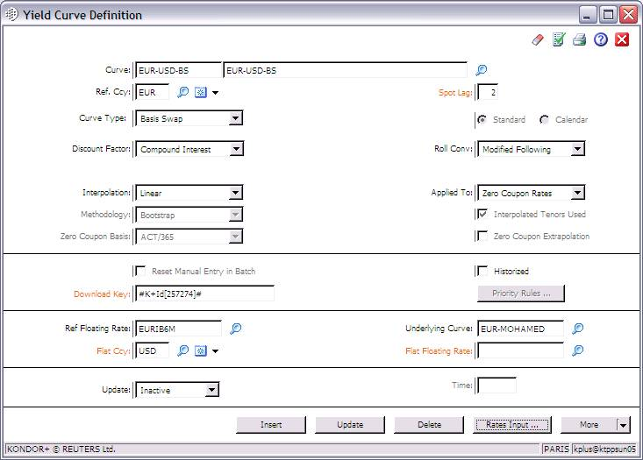
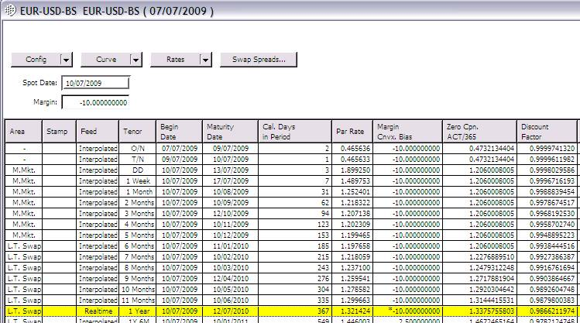
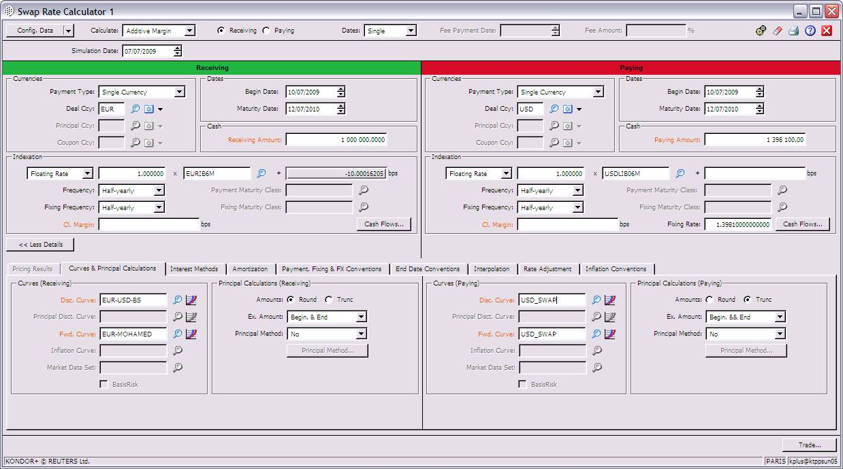

single currency basis swap deals
To be correctly priced by the Basis Swap yield curves, the single currency Basis Swap deals need to have the same assumptions as the curve:
- Principal not exchanged
- Floating Rate = ‘Ref floating Rate’ as in the definition of the curve (same tenor at least)
- Discount Curve = Forward curve for the Flat Leg and are the same as Forward Curve for the Ref Leg = Underlying Curve
- Discount Curve of the Ref Leg = Basis Swap yield curve

cross currency basis swap deals with 2 Basis Swap yield curves
In case we have the following information available in the Market
- 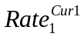vs. 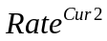Basis Swaps (with Principal exchanged)
- vs. 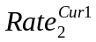Basis Swaps (No Principal exchanged)
Then we can:
  - use the 1st basis swaps to build a Basis Swap yield curve in currency Cur2: BSYC2 (with UC2 as the underlying curve)
  - use the 2nd basis swaps to build a Basis Swap yield curve in currency Cur1: BSYC1 (with UC1 as the underlying curve)
  - price a deal with vs. using the 2 Basis Swap yield curves with the following assignment:
    - cur1 Discount curve = BSYC1
    - cur1 Forward curve = UC1
    - cur2 Discount curve = BSYC2
    - cur2 Forward curve = UC2

